Progress report

My project is based on my research question on non-linear field theory, and I separated it into mainly three relatively independent parts: optimization of the algorithm to find ‘prime orbits’ of a general lattice field theory; parallelization of zeta function coefficient calculation; Markov Chain Monte Carlo (MCMC) simulation on ergodicity of a hyperbolic system (we can understand as a lattice field theory with some constraints on coupling constant so that it possesses good dynamical property mathematically). The first two parts are more like just an application of what I learned in this class to my research, so I mainly focused on the MCMC simulation now.

For this simulation, I applied Metropolis Algorithm that we introduced in the second class of MCMC simulation, inspired by the calculation of expectation value of an ensemble. Currently I am testing whether the algorithm functions well as we expected, so I used a quantum harmonic oscillator as my test case, whose analytical solution is easy to calculate. Based on this result, we hope to develop some criteria so that we can inspect the result for a system (the non-linear field theory system as I proposed) whose property we do not know analytically (possibly not numerically neither). I will mainly cover this topic on this progress report.

For a harmonic oscillator, it has infinitely many energy eigenstates, each with energy $E_{n}=\left(n+\frac{1}{2}\right)ℏω$. This gives a partition function $Z\left(β\right)={\left(e^{\frac{1}{2}βℏω}-e^{-\frac{1}{2}βℏω}\right)}^{-1}$ and expected energy $⟨E⟩ =ℏω(\frac{1}{2}+\frac{1}{e^{βℏω}-1})$, which is related to the expected value of energy level through equation $\left\langle E\right\rangle =ℏω(\frac{1}{2}+\left\langle n\right\rangle )$. Thus, the dimensionless expected value of energy level is given by

$$\left\langle n\right\rangle =\frac{1}{e^{βℏω}-1}$$

We will calculate this number from the simulation because it can be easily generalized to other systems. For simplicity, we will just assume $E_{0}=ℏω$ as some natural unit of energy in the code, which is not very important for our case here. One of the most important parts is to check convergence rate in this kind of simulation, i.e. the length of Markov chain versus expected value. This result is presented below (for ${βE}_{0}=1$, and expectation $\left\langle n\right\rangle =\frac{1}{e-1}$ for 50 simulations, each with a random length of Markov Chain from ${10}^{4.5}$ to ${10}^{7.5}$ presented in log10 scale).

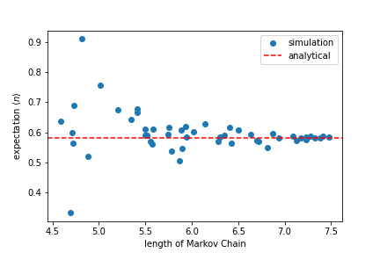

As we can see, the expectation converges to analytical value without a fixed pattern (i.e. converges from above or converges from below), which to some extent proved the randomness that we expected. However, it doesn’t give a good indicator, as we can only manually look at the figure to see this trend of convergence. However, it inspires us to check another quantity. We expected that with a longer Markov chain, the result would be more ‘stable’, from the figure above. Thus, without any information of expectation value, we can repeat each simulation for a given number of times to make a set, and then look at the standard deviation of each set. The result is presented below.

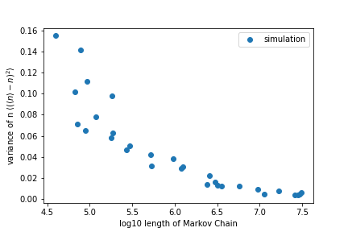

As we can see from this figure, variance (represented by standard deviation) decreases to zero as Markov Chain length increases, so this variance and be an indicator of accuracy, with referring to any known analytical result, which would be important once we apply this model to more complicated systems.

Ideally, I will make similar figures for lattice field theory that we are interested in, with the expected value (horizontal dashed line) calculated from zeta function, both expectation and standard deviation. However, I have not yet decided with quantity to calculate, as zeta function has only been proven suitable for a few expectations. And I am also having some difficulties in assigning weights to each orbit when it come to the calculation of expectation (as each point is an orbit, but orbits might have different lengths). The most importantly, I will try to generate a figure that represent the invariant measure calculated from this simulation, which will look like the figure below but with colored scatters (like a heat map). It will be treated with care once we go through this simulation setup.

